

**UNIVERSITY OF ASIA PACIFIC**

**Department of Computer Science & Engineering**

**Course Title –**  Computer Networks Lab

**Course Code –** CSE 320

**Experiment No. –** 05

**Experiment name –** VLSM and Network Design.

**Submitted by: Submitted To:**

Shawan Das. Dr.A S M Touhidul Hasan

ID –19101020 Assistant Professor,

Section –A1 University of Asia Pacific

**Date of Performance –**  27-02-2022

**Date of Submission –**  05-03-2022

**Problem Statement :** Design a network with VLSM using network address Device: 160.200.0.0/16 & Router-Router network: 11.11.11.0/30 Given Number of host : A=8000, B=5000, C=4000, D=7000, E=2000, F=200, G=500, H=3000, I=120, J=60.

**Network Design :**

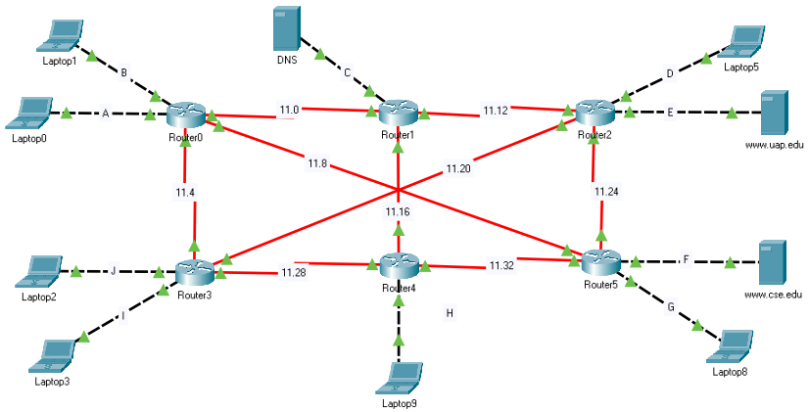

Now we need to complete VLSM with the giver IP addresses and calculate the network address, subnet mask, first IP, last IP, broadcast addresses.

**IP Calculation :**

Given ip for Device: 160.200.0.0/16. first sort network according to their number of host. (Z-A).

**A-8000** [213 CIDR: 32-13]

Here Network part- 19 bit. Host part- 13bit.

Network : 160.200. 0000 0000. 0000 0000= 160.200.0.0/19[host part all 0]

SUBNETMASK: 255.255. 1110 0000. 0000 0000 = 255.255.224.0 [network part 1, host 0]

Broadcast Address: 160.200. 0001 1111. 1111 1111 = 160.200.31.255 [host part all 1]

First Host: 160.200.0.1[Network +1], Last Host: 160.200.31.255[Broadcast -1]

**For another example**, network F: 200[28 CIDR: 32-8]

Network: 160.200.138.0/24

160.200. 1000 1010. 0000 0000= 160.200.138.0/19[host part all 0]

**SUBNETMASK**: 255.255. 255. 0000 0000 = 255.255.255.0 [network part 1, host 0]

**Broadcast Address:** 160.200. 1000 1010. 1111 1111 = 160.200.138.255 [host part all 1]

**First Host:** 160.200.138.1[Network +1], **Last Host:** 160.200.138.254[Broadcast -1]

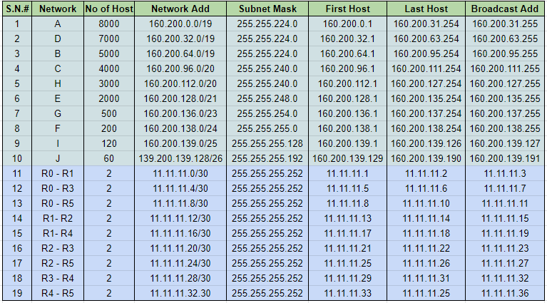

**Server Setup :**

Select server[CSE, UAP, DNS].

Go to Desktop > IP Configuration.

Insert IPv4 address and Default Gateway according to the note.

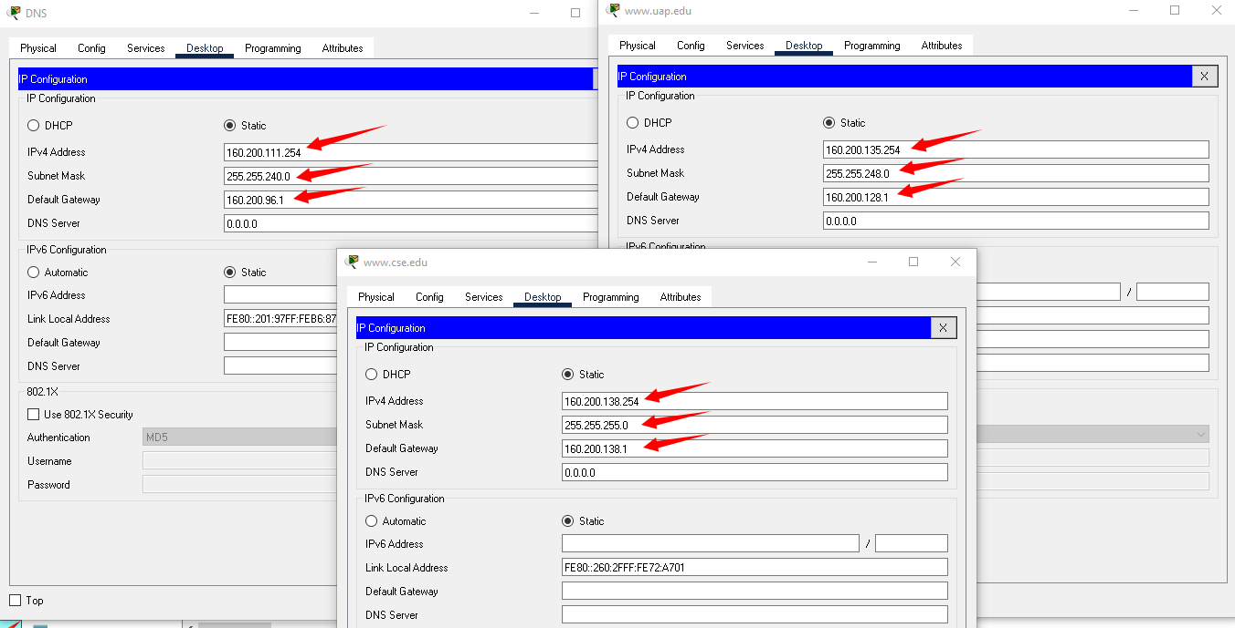

And we are done for server setup.

**PC/Laptop Configuration :**

Now we will configure our PC according to our excel note.

Select a PC to configure.

Desktop > IP Configuration.

Inset IPv4 address, default getway, DNS(160.200.111.254) server according to the note.

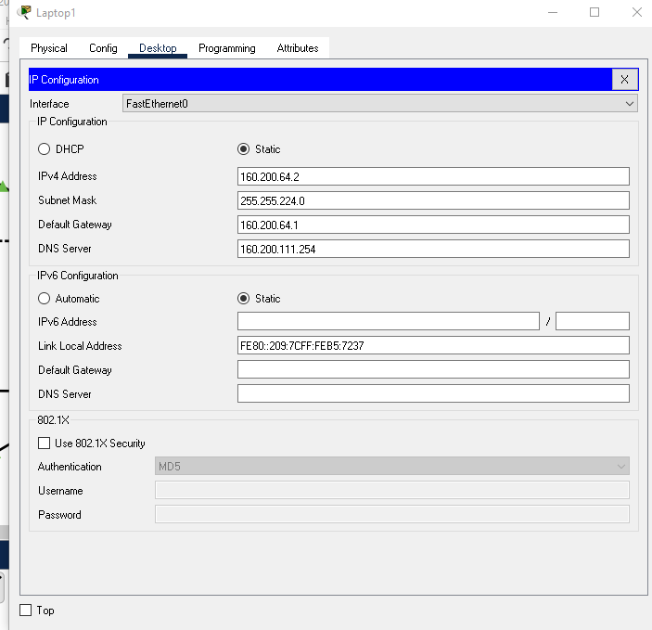

**DNS Configuration :**

Select west server & east server. Then Services > DNS

ON the DNS. Then enter the Name and addresses of CSE,UAP according to the table.

Then click ADD button and you can see the added Name below.

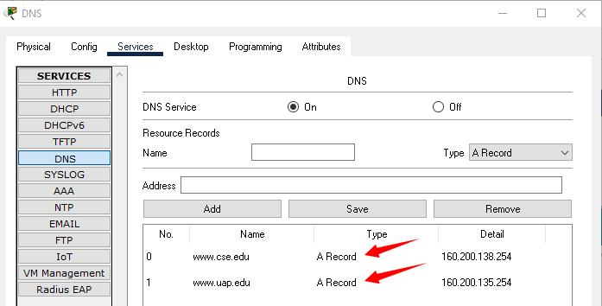

**RIP VERSION-2 Configuration :**

Now we have to establish RIP version-2 configuration to establish a successful communicative connection between all used routers.

Select a router. Then CLI there comes a box where we need to write some code.

Follow the steps:

enable

conf t

router rip

version 2

no auto summary

network 160.200.128.0[for example]

network 11.11.11.4 [for example]

end

to check, if all addresses are assigned correctly use “show ip route command”.

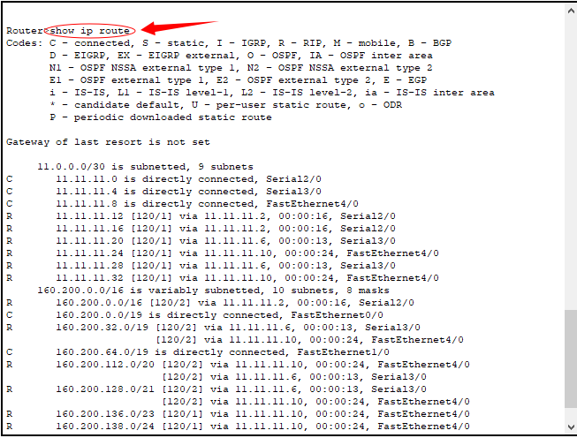

if everything is ok, we are good to go for web search.

Now we just need to select any PC and search for the addresses [www.cse.edu](http://www.cse.edu) , [www.uap.edu](http://www.uap.edu) .if it shows the web page, then our objective is successful.

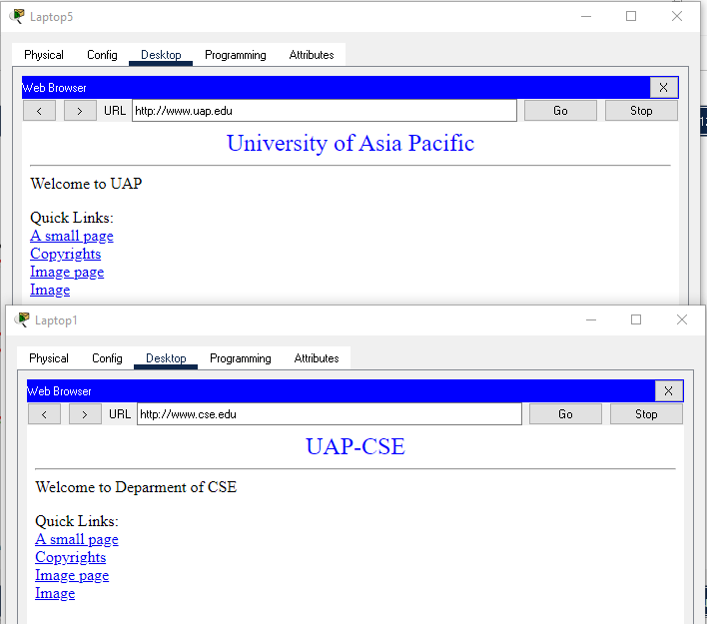

**Learning :**

In this experiment, we learned about VLSM and it’s use.

**Discussion:**

It may take some time to establish a connection. Please wait until the node of the connection turns green. Be careful with cross-over & Straight through connection. Same Type Device- Cross-over, different type device: Straight - Through connection. Be careful when you are adding networks in RIP configuration. You can also use [show ip route] before doing rip con fig. It will show you which networks are connected with the router and it will be easy for you to know which network you should add for RIP. Send packages from PC to PC or use Command prompt to check the connection between devices. If there were any kind of error, check the IPV4 addresses. Try to use switch-2960 with 24-ports.